**Name: Muhammad Kaleem Ullah Reg. No.# FA19-BCE-007**

**Lab#06**

**Inheritance**

1. **In-Lab Tasks:**

**Task#1:** Imagine a publishing company that markets both book and audiocassette versions of its works. Create a class publication that stores the title (a string) and price (type float) of a publication. From this class derive two classes: book, which adds a page count (type int), and tape, which adds a playing time in minutes (type float). Each of these three classes should have a getdata() function to get its data from the user at the keyboard, and a putdata() function to display its data.  
Write a main() program to test the book and tape classes by creating instances of them, asking the user to fill in data with getdata() , and then displaying the data with putdata() .

* **Code:**

#include<iostream>

#include<string>

using namespace std;

class publication

{

private:

string title;

float price;

public:

void getData()

{

cin.ignore();

cout<<"\nEnter The Title of the Book : "; getline(cin,title,'\n');

cout<<"\nEnter the Price of the Book : "; cin>>price;

}

void putData()const

{

cout<<"\nTitle of the book is : "<<title;

cout<<"\nPrice of the book is : "<<price;

}

};

class sales

{

private:

enum { MONTHS = 3 };

float salesArr[MONTHS];

public:

void getData();

void putData() const;

};

void sales::getData()

{

cout << " Enter sales for 3 months\n";

for(int j=0; j<MONTHS; j++)

{

cout << " Month " << j+1 << " : ";

cin >> salesArr[j];

}

}

void sales::putData() const

{

for(int j=0; j<MONTHS; j++)

{

cout << "\n Sales for month " << j+1 << ": ";

cout << salesArr[j];

}

}

class book:public publication,public sales

{

private:

int pageCount;

public:

void getData()

{

publication::getData();

cout<<"\nEnter the Number of Pages of the Book : "; cin>>pageCount;

sales::getData();

}

void putData()const

{

publication::putData();

cout<<"\nThe Number of pages of book are : "<<pageCount;

sales::putData();

}

};

class tape:public publication,public sales

{

private:

float minutes;

public:

void getData()

{

publication::getData();

cout<<"\nEnter the Audio Minute of the Book : "; cin>>minutes;

sales::getData();

}

void putData()

{

publication::putData();

cout<<"\nThe Number of Minute of this Audio Book are : "<<minutes;

sales::putData();

}

};

int main()

{

int n;

cout<<"\nHow many Book's Data You Want To Enter : "; cin>>n;

book b[n];

tape t[n];

for(int i=0;i<n;i++)

{

cout<<"\nEnter the Books Data : ";

b[i].getData();

cout<<endl;

cout<<"\nEnter the Tape Data : ";

t[i].getData();

}

system("CLS");

for(int i=0;i<n;i++)

{

cout<<endl;

cout<<"\nStore Data : ";

cout<<"\nBook information: ";

cout<<endl;

b[i].putData();

cout<<"Tape Information : \n ";

t[i].putData();

}

return 0;

}

* **Output:**

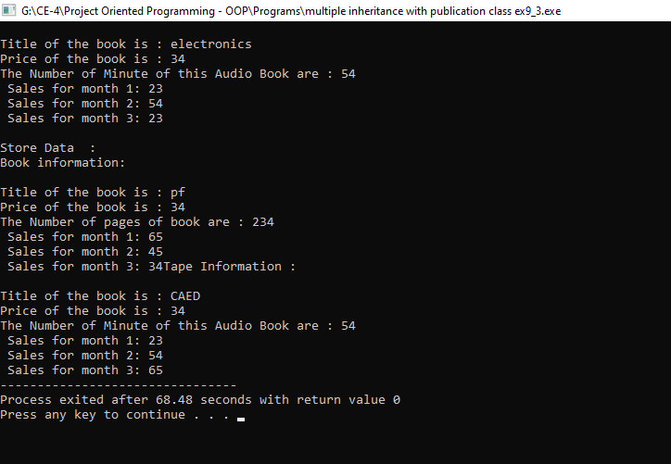

**2)-** Assume that the publisher in task 1 decides to add a third way to distribute  
books: on computer disk, for those who like to do their reading on their laptop. Add a  
disk class that, like book and tape, is derived from publication. The disk class should  
incorporate the same member functions as the other classes. The data item unique to this class is the disk type: either CD or DVD. You can use an enum type to store this item. The user could select the appropriate type by typing c or d.

* **Code:**

#include<iostream>

#include<string>

using namespace std;

class publication

{

private:

string title;

float price;

public:

void getData()

{

cin.ignore();

cout<<"\nEnter The Title of the Book : "; getline(cin,title,'\n');

cout<<"\nEnter the Price of the Book : "; cin>>price;

}

void putData()const

{

cout<<"\nTitle of the book is : "<<title;

cout<<"\nPrice of the book is : "<<price;

}

};

class sales

{

private:

enum { MONTHS = 3 };

float salesArr[MONTHS];

public:

void getData();

void putData() const;

};

void sales::getData()

{

cout << " Enter sales for 3 months\n";

for(int j=0; j<MONTHS; j++)

{

cout << " Month " << j+1 << " : ";

cin >> salesArr[j];

}

}

void sales::putData() const

{

for(int j=0; j<MONTHS; j++)

{

cout << "\n Sales for month " << j+1 << ": ";

cout << salesArr[j];

}

}

class book:public publication,public sales

{

private:

int pageCount;

public:

void getData()

{

publication::getData();

cout<<"\nEnter the Number of Pages of the Book : "; cin>>pageCount;

sales::getData();

}

void putData()const

{

publication::putData();

cout<<"\nThe Number of pages of book are : "<<pageCount;

sales::putData();

}

};

class tape:public publication,public sales

{

private:

float minutes;

public:

void getData()

{

publication::getData();

cout<<"\nEnter the Audio Minute of the Book : "; cin>>minutes;

sales::getData();

}

void putData()

{

publication::putData();

cout<<"\nThe Number of Minute of this Audio Book are : "<<minutes;

sales::putData();

}

};

/* Assume that the publisher in task 1 decides to add a third way to distribute

books: on computer disk, for those who like to do their reading on their laptop. Add a

disk class that, like book and tape, is derived from publication. The disk class should

incorporate the same member functions as the other classes.

The data item unique to this class is the disk type: either CD or DVD. You can use an enum type to store this item.

The user could select the appropriate type by typing c or d.

*/

class disk:public publication,public sales

{

private:

enum Disk{cd, dvd};

Disk e;

char ch;

public:

void getData()

{

cout<<"Enter 'c' to select CD or 'd' for DVD : ";

cin>>ch;

if(ch == 'c')

{

e=cd;

}

if(ch == 'd')

{

e=dvd;

}

}

void putData()

{

if(ch == 'c')

{

cout<<"CD";

}

if(ch == 'd')

{

cout<<"DVD";

}

}

};

int main()

{

int n;

cout<<"\nHow many Book's Data You Want To Enter : "; cin>>n;

book b[n];

tape t[n];

disk d[n];

for(int i=0;i<n;i++)

{

cout<<"\nEnter the Books Data : ";

b[i].getData();

cout<<endl;

cout<<"\nEnter the Tape Data : ";

t[i].getData();

cout<<"\nEnter the Disk Data : ";

d[i].getData();

}

system("CLS");

for(int i=0;i<n;i++)

{

cout<<endl;

cout<<"\nStore Data : ";

cout<<"\nBook information: ";

cout<<endl;

b[i].putData();

cout<<"Tape Information : \n ";

t[i].putData();

cout<<"\nDisk Data : ";

d[i].putData();

}

return 0;

}

* **Output:**

Output screen is bigger to cover in in snap so I am pasting the last part of that which is displacing the result:

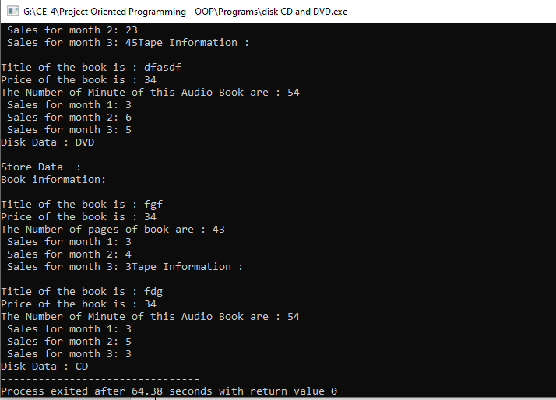

**3)-** Design a class namedPersonData with the following member variables:

* lastName
* firstName
* address
* city
* state
* zip
* phone

Write the appropriate accessor and mutator functions for these member variables.

Next, design a class named CustomerData, which is derived from the PersonData

class. The CustomerData class should have the following member variables:

* customerNumber
* mailingList

The customerNumber variable will be used to hold a unique integer for each customer.

The mailingList variable should be a bool. It will be set to true if the customer

wishes to be on a mailing list, or false if the customer does not wish to be on a mailing list. Write appropriate accessor and mutator functions for these member variables.

Demonstrate an object of the CustomerData class in a simple program.

* **Code:**

#include<iostream>

#include<string>

using namespace std;

class PersonData

{

private:

string lastName;

string firstName;

string address;

string city;

string state;

string zip;

string phone;

public:

void getData()

{

cout<<"\nEnter the First Name : "; getline(cin,firstName,'\n');

cout<<"\nEnter the Last Name : "; getline(cin,lastName,'\n');

cin.ignore();

cout<<"\nEnter the Address : "; getline(cin,address,'\n');

cin.ignore();

cout<<"\nEnter the City : "; getline(cin,city,'\n');

cin.ignore();

cout<<"\nEnter the State : "; getline(cin,state,'\n');

cin.ignore();

cout<<"\nEnter the Zip Code : "; getline(cin,zip,'\n');

cin.ignore();

cout<<"\nEnter the Phone Number : "; getline(cin,phone,'\n');

cin.ignore();

}

void putData()

{

cout<<"\nYour First Name : "<<firstName;

cout<<"\nYour Last Name : "<<lastName;

cout<<"\nYour Address : "<<address;

cout<<"\nYour City : "<<city;

cout<<"\nYour State : "<<state;

cout<<"\nYour Zip Code : "<<zip;

cout<<"\nYour Phone Number : "<<phone;

}

};

class CustomerData:public PersonData

{

private:

int customerNumber;

int mailingList;

public:

void getData()

{

PersonData::getData();

cout<<"\n Please enter Customer Nubmer : "; cin>>customerNumber ;

cout<<"\n Mailing List Service Preferacne : ";

cout<<"\n Do you want to get add in mailing list : ";

cout<<"\n if No, Enter any key, if Yes, Enter '1'"; cin>>mailingList;

}

void putData()

{

cout<<"\nYour Customer Service Number : "<<customerNumber;

PersonData::putData();

if(mailingList==1)

{

cout<<"\n\t You Have Subscribed For Mailing Service";

}else

{

cout<<"\n\t You Haven't Subscribed For Mailing Service";

}

}

};

int main()

{

CustomerData c1;

c1.getData();

c1.putData();

return 0;

}

* **Output:**

